**CP4I Operations Dashboard Installation**

1. Login into Openshift Console

2. Expand **Operators** and Click **OperatorHub**.

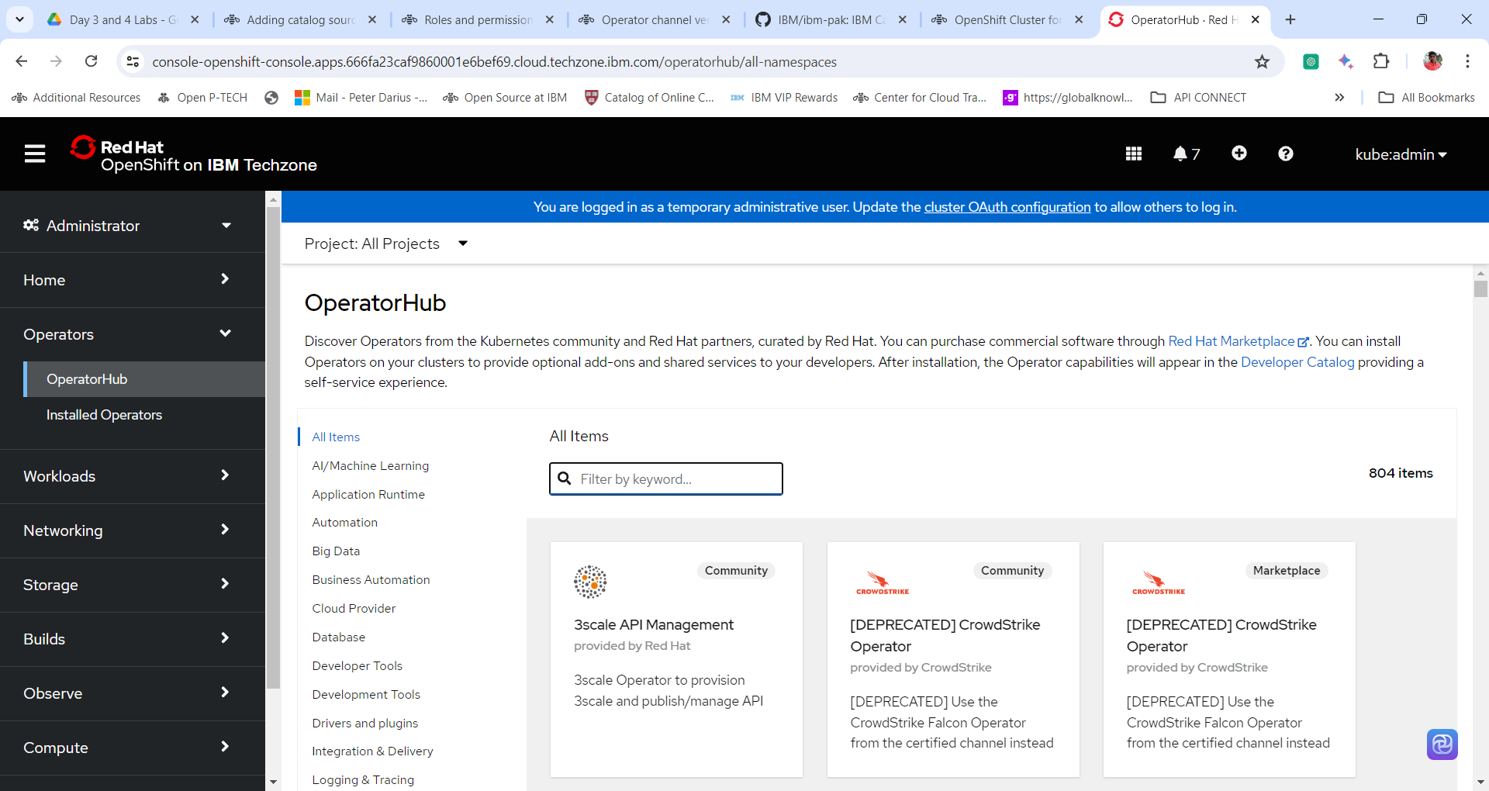

3. Under All Items search for **Operations Dashboard**. And click on the Tile **IBM Cloud Pak for Integration Operations Dashboard**.

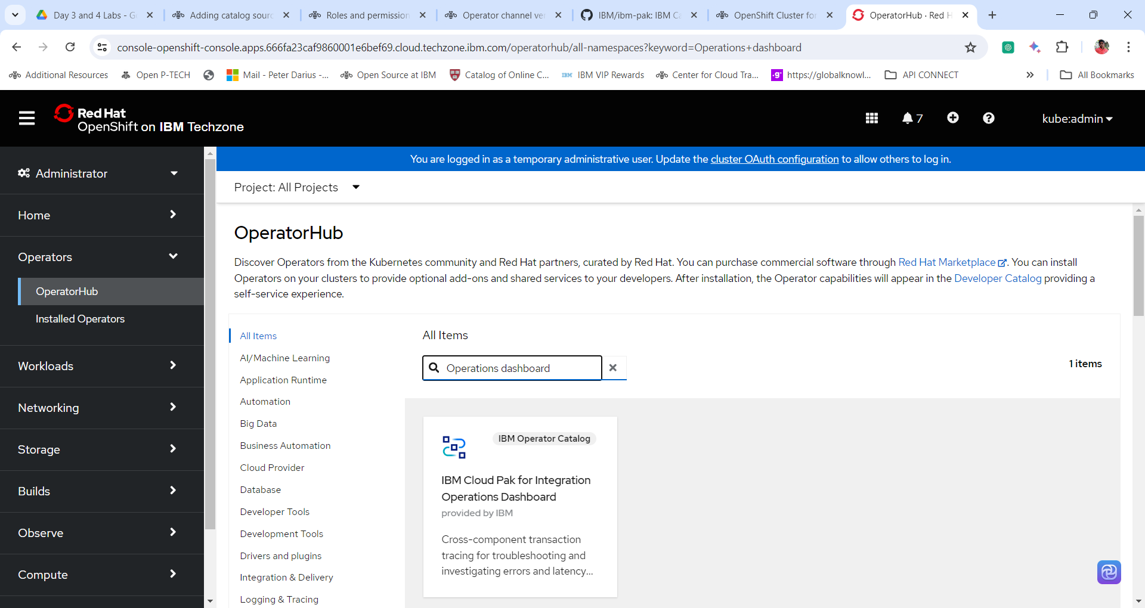

4. Peruse the details of Operations Dashboard box and Click **Install.**

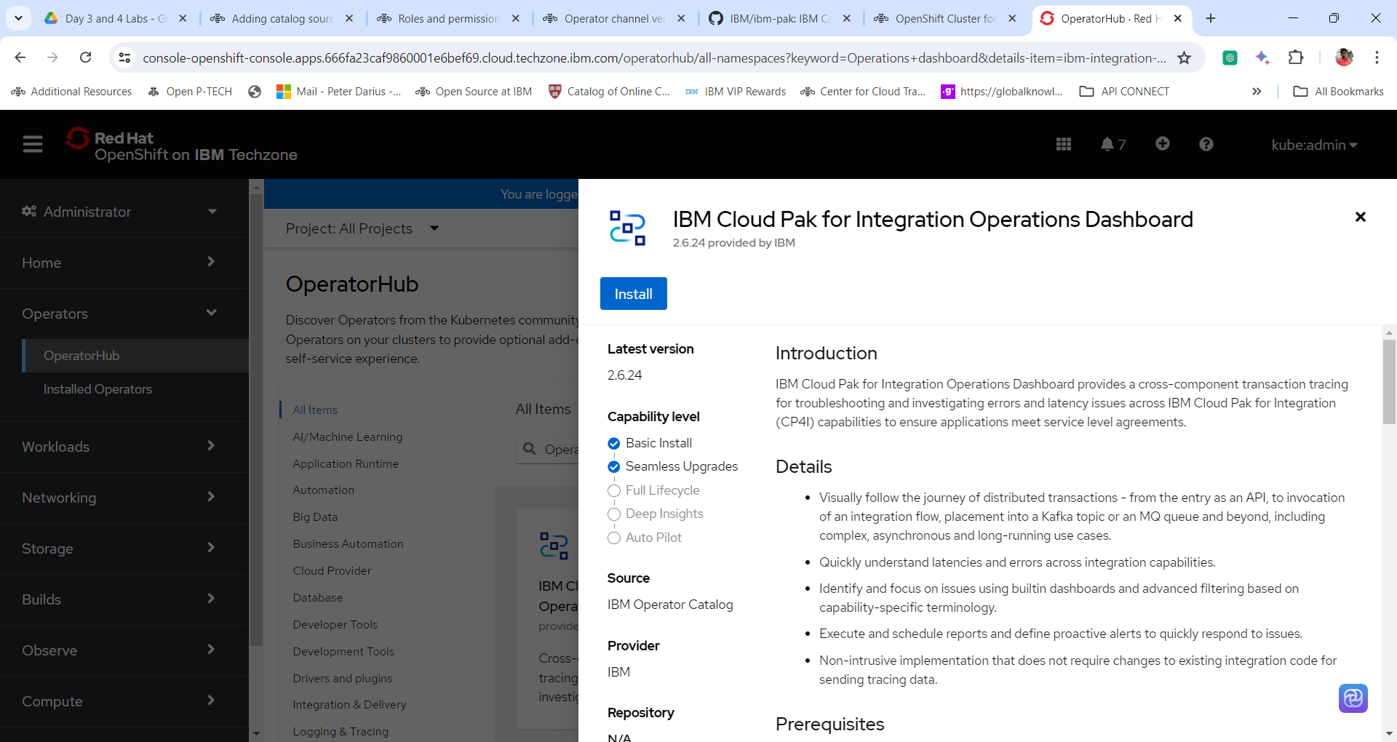

5. Select the following configuration and Click Install.

**Update Channel = v2.6lts**

**Installation Mode = All namespace in the Cluster**

**Installed Namespace = OpenShift-operators**

**Update Approval = Automatic**

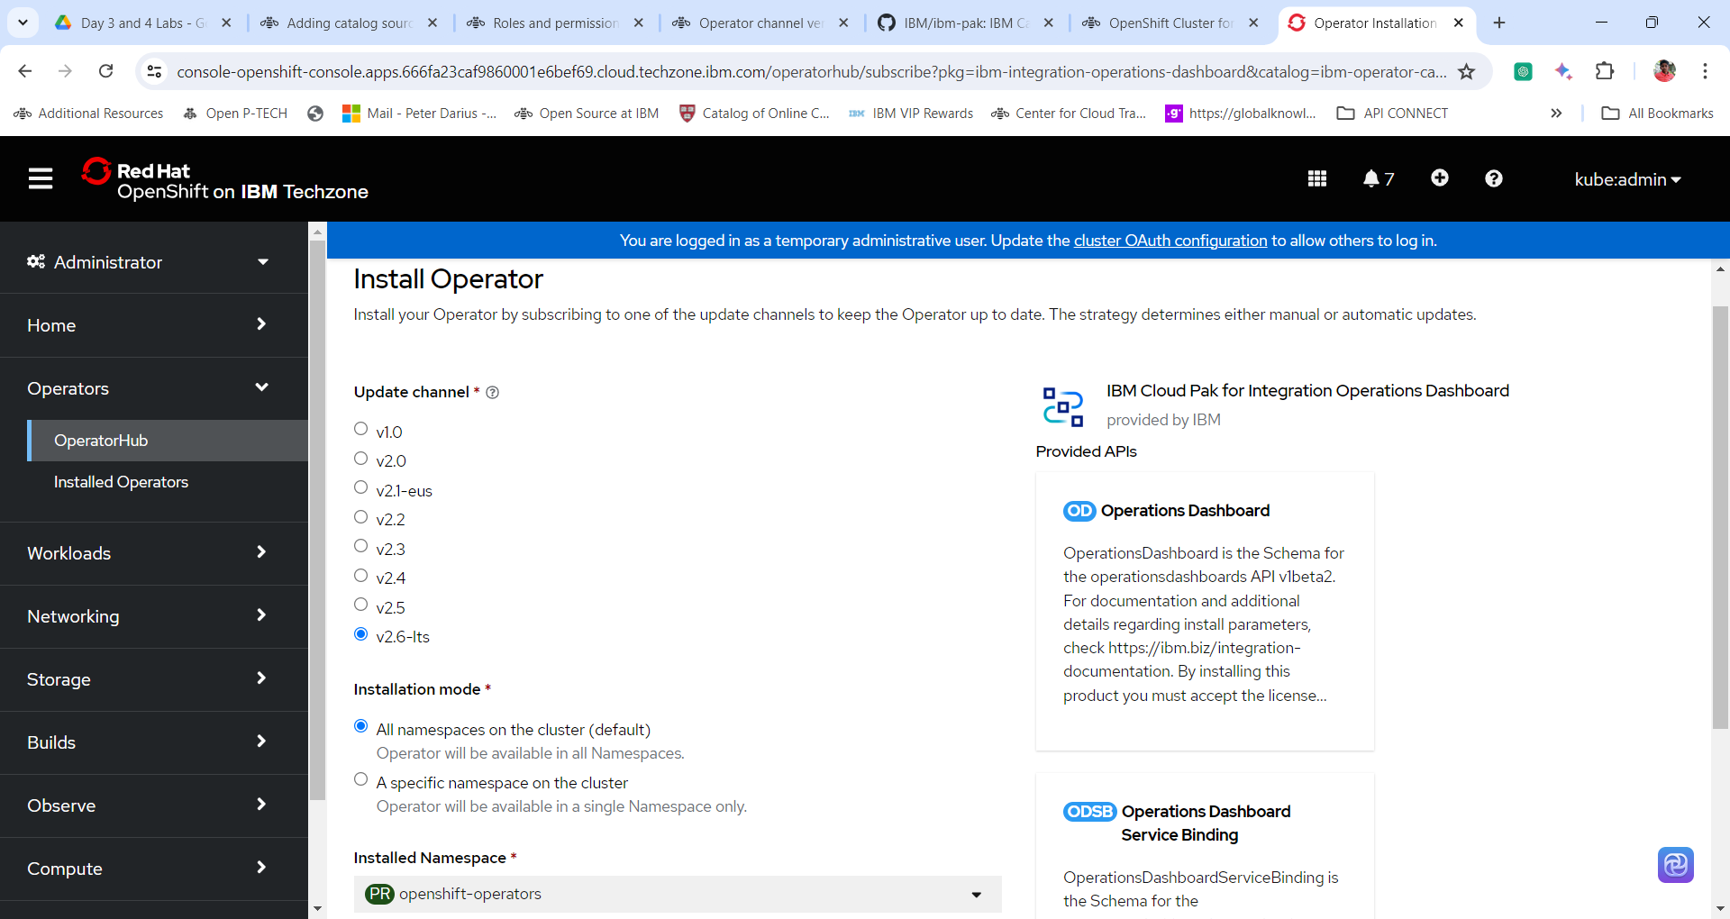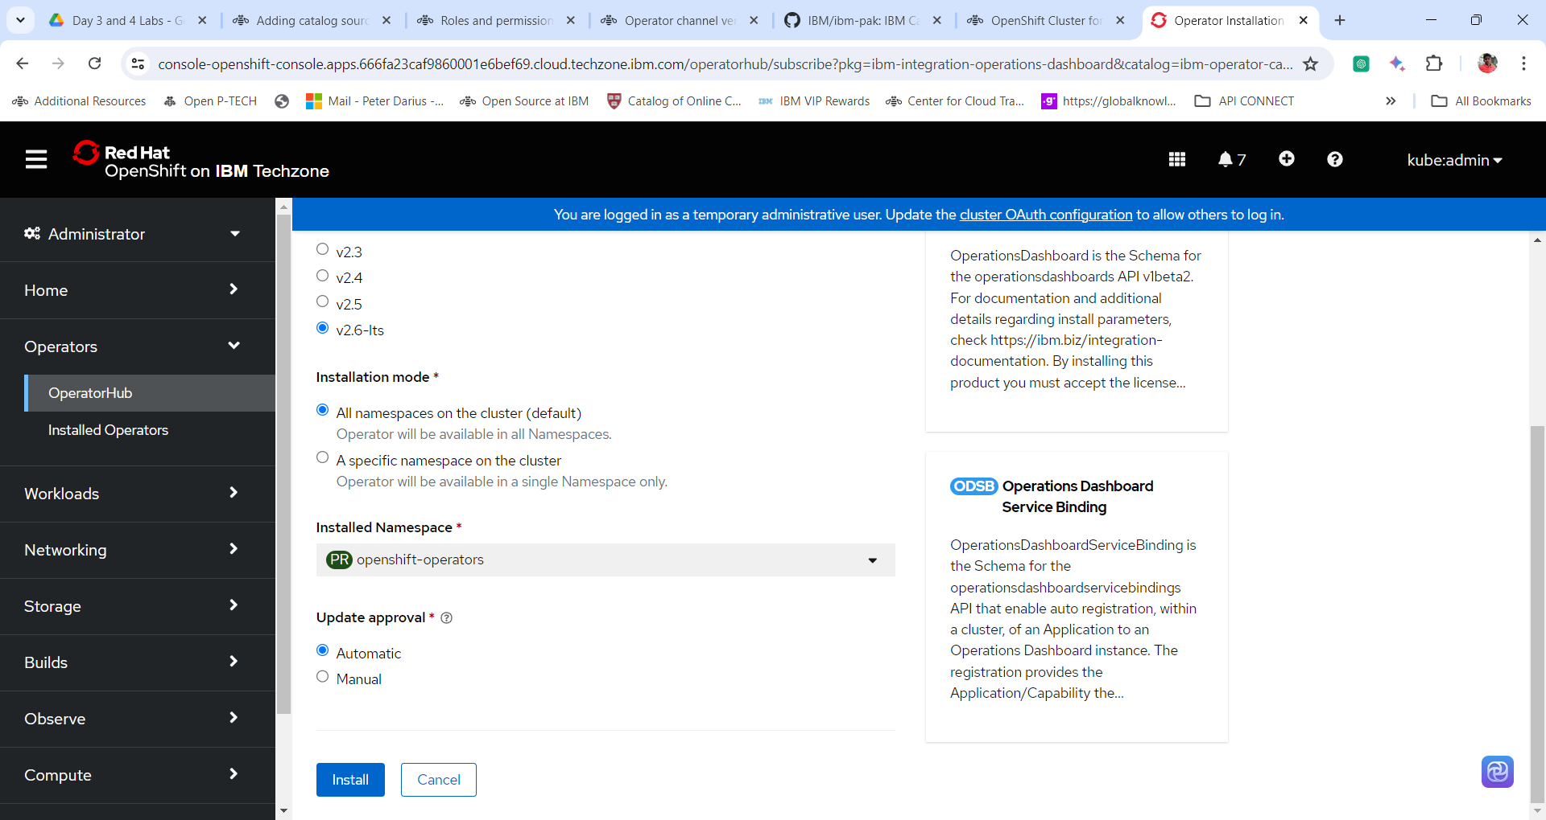

6. Wait for the installation to be completed successfully.

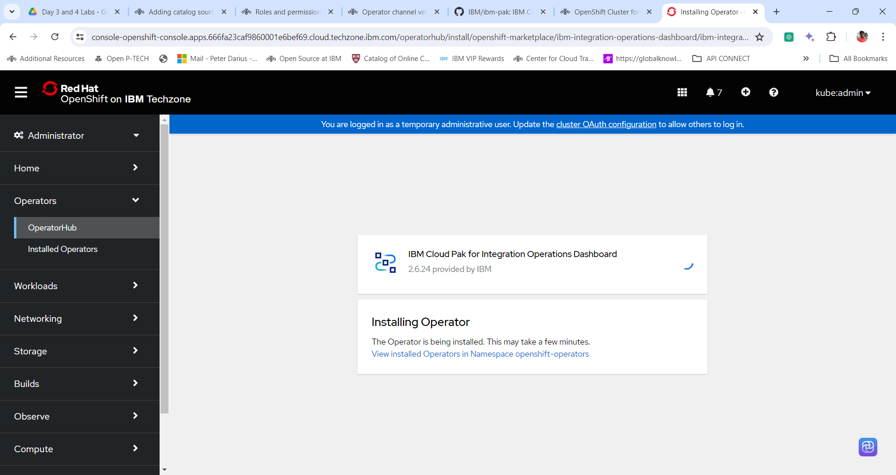

7. Click on **View Operator** to view the details of the installed operator.



